Name (Last, First (printed))

Section Number Student ID#

Score Received

PROJECT 9: Using a DATABASE - NeoOffice
Attach this coversheet to the top of your project.

This project is to be completed in the scheduled lab at the time for which you have enrolled.
Ethics statement: (please sign in the space provided)
I, __________________________ by signing this form, state that the project submitted here is of my own effort.
Please initial all areas where you have completed the items listed:

Prelab # points
Pre-lab completed BEFORE coming to the lab 2

Form Output (1st printout - Landscape)
Includes at least 6 records 3
Includes at least 8 fields with names of fields showing 4
Includes at least 1 date field, 1 numeric field and 1 text field 3
All field contents visible – no fields are truncated 1
Printed in Landscape orientation 1

Report Output (2nd printout - Portrait)
Displays 4 fields in 2 column with names of fields showing 2
Displays all records 1
Printed in Portrait orientation 1
Displays date and time in the header 1
Displays page number in the footer 1

IF you need a late pass, see your instructor or lab leader (with documentation). Otherwise, the following reduction of points will apply:
________ Late, but turned in within one week after the project’s due date loss of 10 points
________ Too late. Turned in after the one week deadline loss of 19 points

Database Project Pre-lab

For this exercise, you will design your own database. Think of a collection you have or would like to have. All items in your collection have common characteristics. Each of these characteristics will be a separate field in your database. Each item’s description forms a database record of that item.
- A database is a collection of information. This information is stored in one or more records. A record is a complete set of information about one person or item. A field is one piece of information, about that person or item. For each field, you define the type of contents. The different types used in this project are text, numeric, or date. Text is just the ASCII codes used in word processing. Numeric data means numbers either fractions or non-fractions. Dates and the many forms they can be written are the third type of data we will use. You will need at least one of each of these three types in your database for this project. For example:
- Names and addresses are Text
- Birth dates are in a Date format
- Zip codes are Text – because of zip codes like 08347 or N6Y 3G6 (Canada)
- Cost should be Numeric with an Appearance of dollars and cents
- Phone number is not numeric because of the dash, so use text instead
- Decide what type of data you are collecting and what fields of information will be needed. Your database must have at least 6 records with each record having at least 8 fields. Your data must include at least one numeric field, one date field and one text field in the database.
- Database suggestions: Name and address database, Audio or CD collection, Gift list, Automobile or bike parts and price listing, College course listing, Household electronic equipment inventory (for insurance purposes).
- Field names might include (but are not restricted to) the following: Last, First, Address, DOB, Account Balance, Part Name, Date Purchased, Cost, Semester.
- You will NEED to have a unique identifier for each record, like an ID number. This will be your "primary key". (This can also be your numeric value if you choose to use a number.)

What will be the topic of your database?______________________________________ (NOTE! Check with your instructor or lab leader. The example given in class may not be acceptable for credit.

Complete the following chart: Include at least 8 fields.

The field name (Keep field-names to 10 chars!) The “field-type”. (Text, Date or Numeric)

1)

2)

3)

4)

5)

6)

7)

8)

9)
10)

Record 1 Record 2

Record 3 Record 4
Field names: Contents of fields:
Field names: Contents of fields:
Field names: Contents of fields:
Field names: Contents of fields:
Field names: Contents of fields:
Field names: Contents of fields:

Record 5 Record 6

DATABASE
Continue on with this section only after you have completed the previous pages. Once you have filled out the charts, you are prepared to continue on and start using the program.

Project description:
We will use the open-source NeoOffice program for this project. You will enter information about your collection of like-things into the database module. You will then organize the data with the help of NeoOffice and print out the organized database.

The sections described later in this project are:
1. Open a new blank database document.
2. Prepare the database document for entering data.
3. Entering data into the database.
4. Creating a form (for the purposes of printing out the contents of your database.)
5. Printing out your new form.
6. Creating a report (to print out the contents of your database in a report format.)
7. Printing out the report.

1. Open a new blank database document:
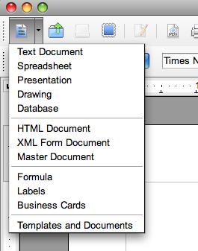
a. Open NeoOffice.
b. Select a new Database module.
This can be done in two ways:
1) From the File menu, select New and drag the cursor over to Database.
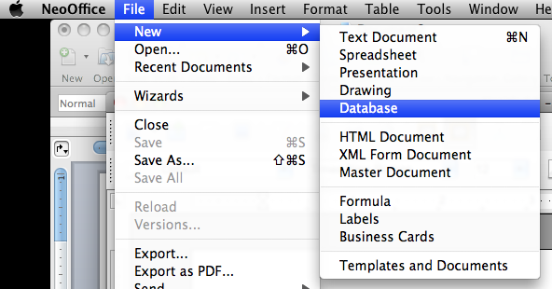
2) From the "new document" icon, select Database.
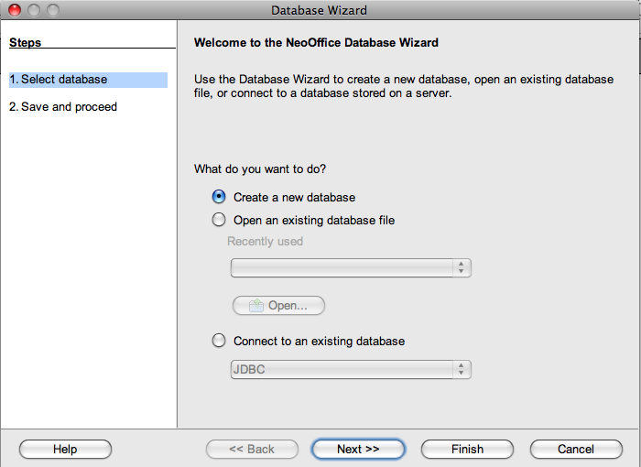

2. Prepare the database document for entering data:
a) Follow the directions to create your new database.
- In this first window, select "Create a new database". Make sure nothing else is selected.
- Click on the Next button

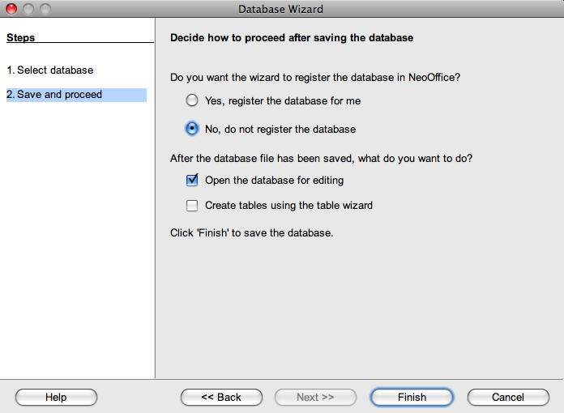
b) In this second window, make the following selections:
- No, do not register
- Open the database for editing
- Click on the Finish button

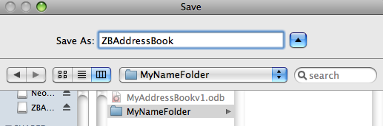
c) Save your new database:
- In the Save window,
- Find your folder on the Scratch disk.
- Save your database file with a new name that will reflect the purpose of your database.
- Click the Save button.

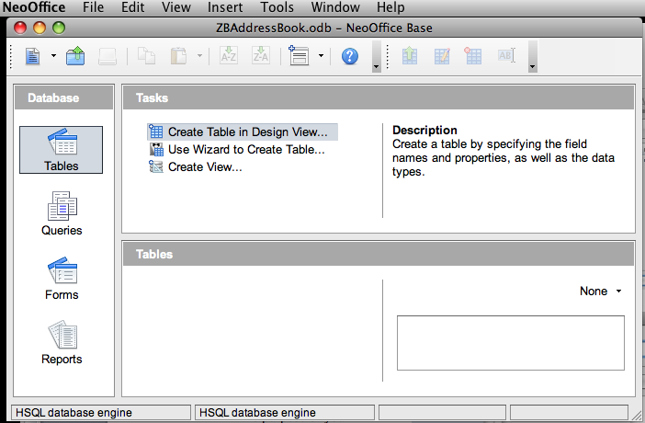
d) Define the fields for your records:

- With the Tables icon selected,

- Select: "Create Table in Design View".

e) For AT LEAST 8 FIELDS… Enter the names and types of each field: You must have at least one text field, at least one date field, and at least one numeric field (this example uses a "Small Integer" – This integer will be only 5 symbols wide)
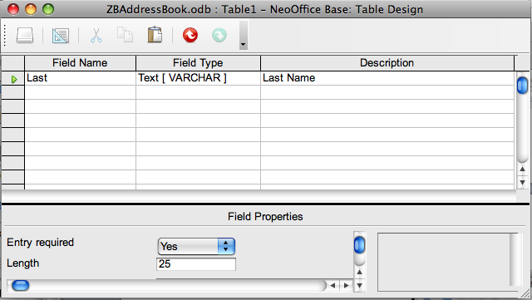
- Under Field Name, enter the name of each field
- Under Field Type, select the field type from the menu (to change the type from text, double-click in the field type box and select the new type)
- Enter a description for field names that are shortened
- Enter the field length if you would like. The default for text is 100 characters wide. You can leave it this way or shorten it. It is up to you.

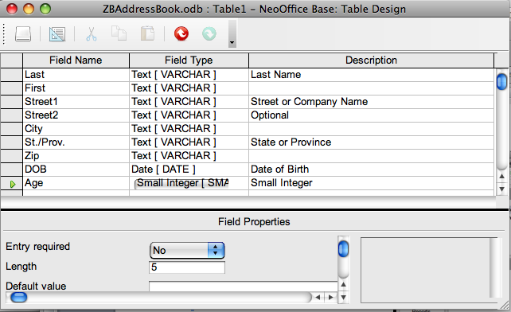
Your fields should be defined to look something like this (but reflecting field names for YOUR database!!!)

Before you continue:

PICK a field that would be the best fit for your "Primary Key".
Your primary key is a field that has a UNIQUE value, like an ID number. (For example: You can't use last name if you have more than one person with the same last name.)
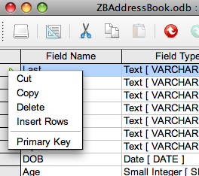
f) Select your Primary Key. (MUST be Unique!)
- Click the mouse in the box to the left of your choice as the primary key. (In this database, the Last name is selected. This is not a wise choice if you have more than one person with the same last name. Your primary key must have a unique value. It would have been better if this were some type of ID number.)
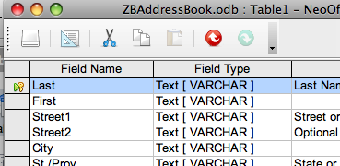
- In the box to the left of the field that you have selected to be your primary key, press the right mouse button (or, on a Mac, hold the ctrl key down and press the mouse).
- In the menu, select Primary Key.

- You should now have a small "key" icon next to the field you have selected.

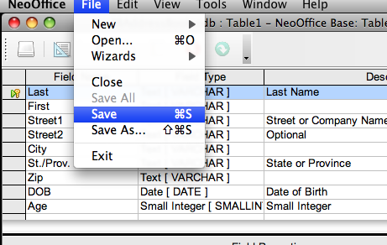
g) Save your defined fields.
- From the File menu, select Save.

SAVE your work OFTEN. The changes you make will not be saved if the computer crashes!

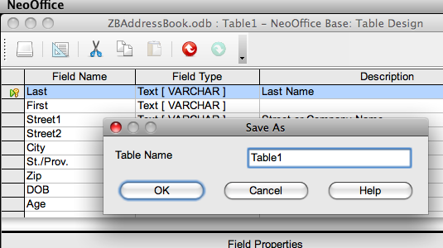
h) Select a new name for this definition screen and save it as directed. (The name you select should appear in the table module list.)

You are now ready to enter the data into your database.

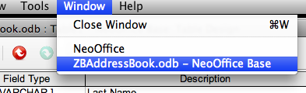
3. Entering data into the database.

a) From the Window menu, select the name you gave to your database. (This will bring up the main database window.)

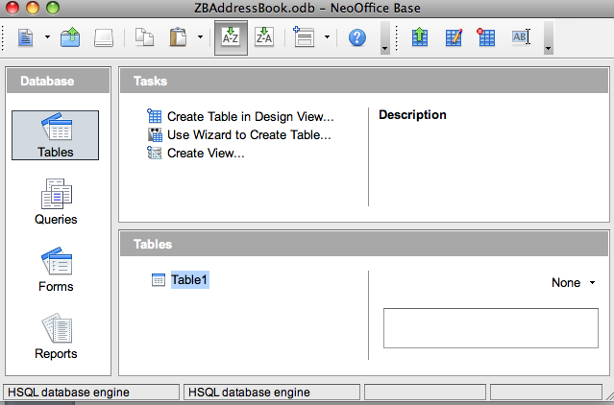
b) With the Table icon selected, the table module list will be displayed in the lower portion of the window.
- Double-click on the name of the new module you have just saved.
Whatever name you just gave it…

c) Fill in the contents of the fields for AT LEAST 6 records.
- You MAY need to expand or condense the widths of the fields to match your data.
- Save the changes after entering the contents in your last field.

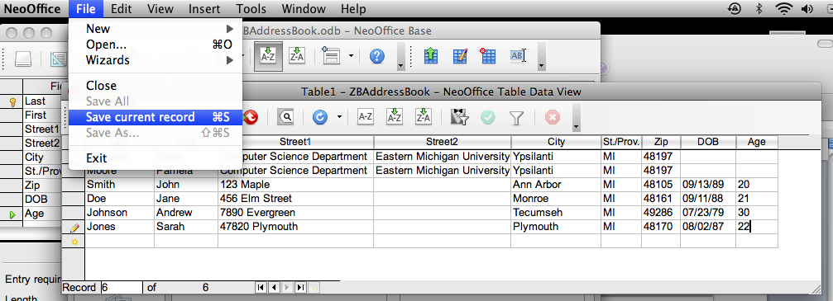
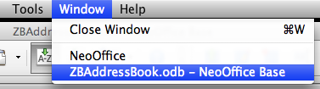
d) Go back to the main database window to make more changes to the database.
- From the "Window" menu, select the name that you saved as your database.

NOTE: Whenever you return to this MAIN Window, SAVE the changes that you had just made to your database. It is a lot of saving, but better "save" than sorry. ☺

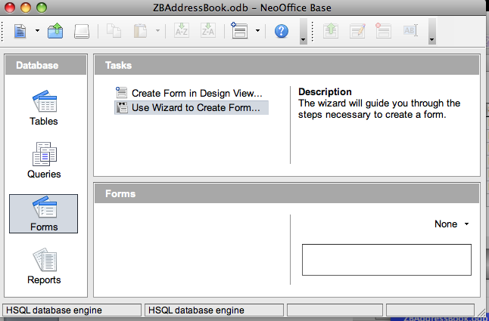
4. Create a new FORM for your database.

a) Click on the Forms icon.
b) Click on "Use Wizard to Create Form"
b)

aa)

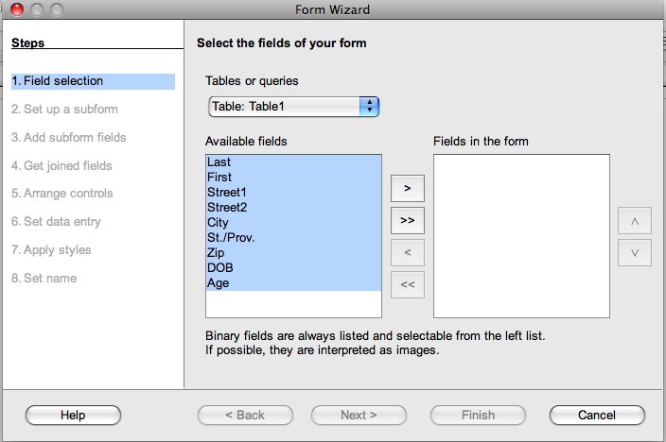
c) Select all of your fields (These will be included in your new form.)
d) Click on the arrow to move your selection to the right side of the window.
e) Click on the Next button to continue.

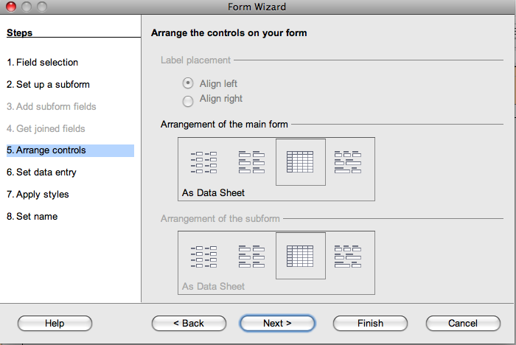
f) Make no selections in the Subforms window (You are not adding a subform. Just click next.)

g) Leave the default columnar format for your new form and click on Next.

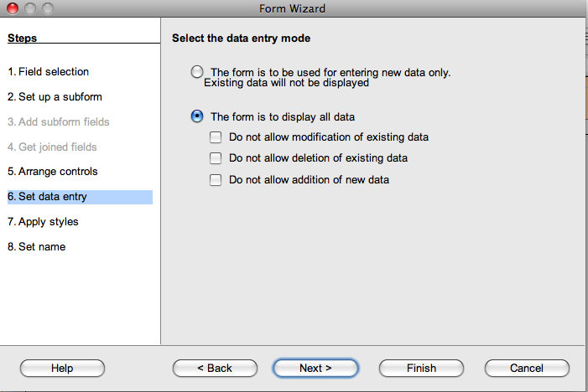

h) In the "data entry mode" screen, leave the default settings as shown here.
- Click on Next to continue.

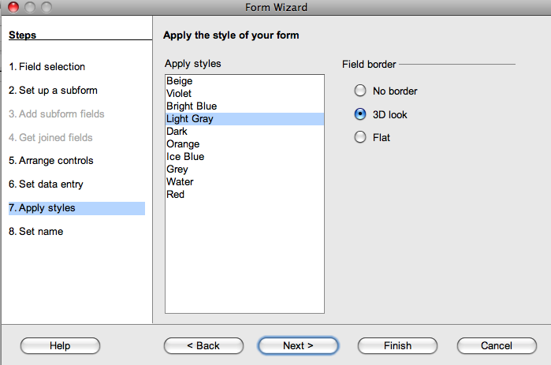
i) Select your choice of style for color and borders.

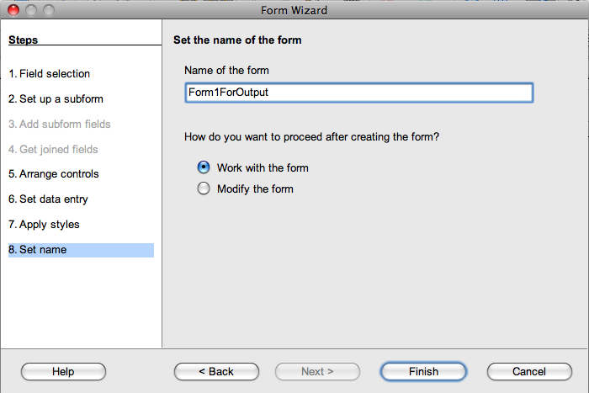
j) Name the form:
- Name it something different from the default not to be confused with the table you had just created. SUGGESTION: FormForOutput (as shown).

- Select "Work with the form"
- Click on Finish

5. Printing out your new form.

a) Go back to the main database window.

REMEMBER to save when you come back to your MAIN window - It will save the Form you just created in case the computer crashes.

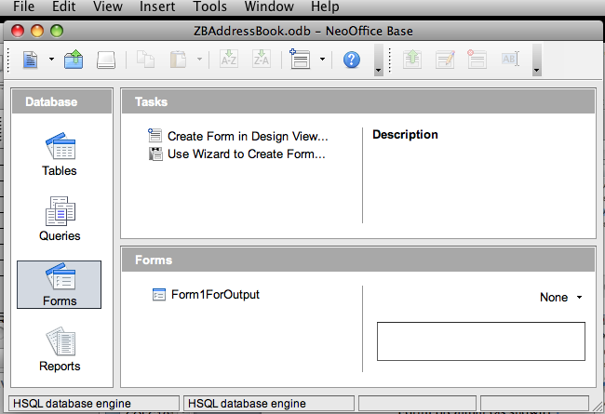
b) Double-click on the Form you just created to open it in a new window.
- You will need to clean it up before printing.
- Stretch those fields that are too narrow.
- Decrease the width of those fields that are too wide.

c) Preview to check your page layout.
- From the File menu, select Print.
- Select Print Preview.

d) If you are satisfied with the layout (nothing is cut off or too wide), then Print out the page. Otherwise, cancel the print job and fix the layout and try again.

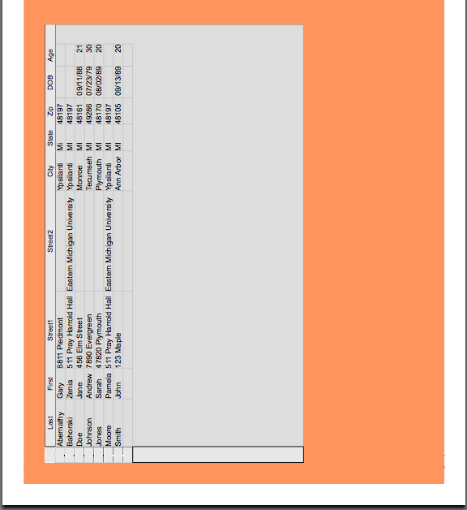
e) This is your first printout. Continue on to print out a report.

The picture on the right is only a partial image of the landscape printout of the sample document.

6. Creating a report (to print out the contents of your database in a report format.)
a) Go back to the main database window.
Select your database from the menu.
Select the name of your database

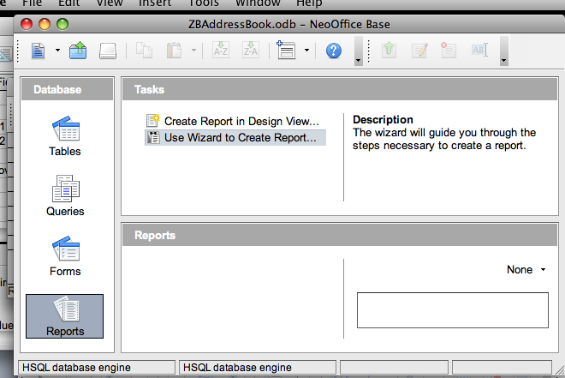
b) Create a new report.
- Select the Reports icon
- Click on "Use Wizard to Create Report"

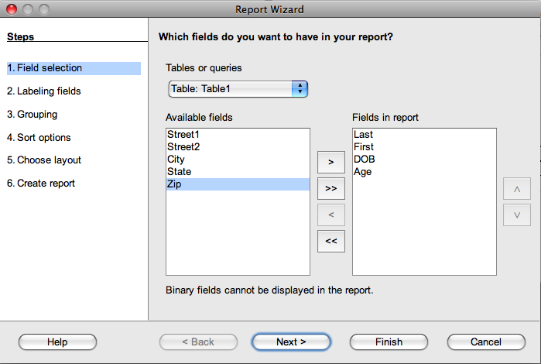
c) Select only 4 fields to be in this new Report.

- Highlight the 4 fields you wish to include
- Click on the arrow to send the fields to the right side of the window.
- Click on Next.

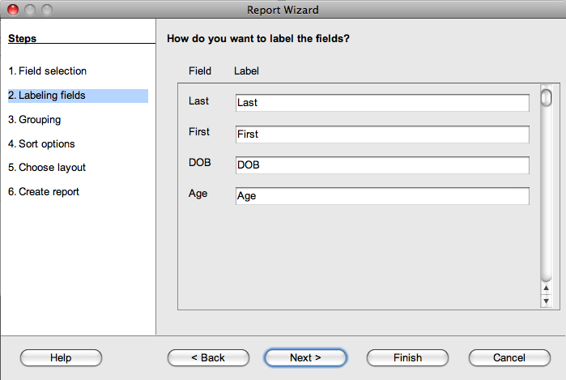
d) This next window asks how you wish to label your fields. If you are happy with the field names, you do not need to do anything here. You may update the names of the fields for this report if you wish to clarify the contents of the fields.
- Click on Next to proceed to the next screen

e) Skip the grouping levels screen. (Click on Next to bypass this screen).

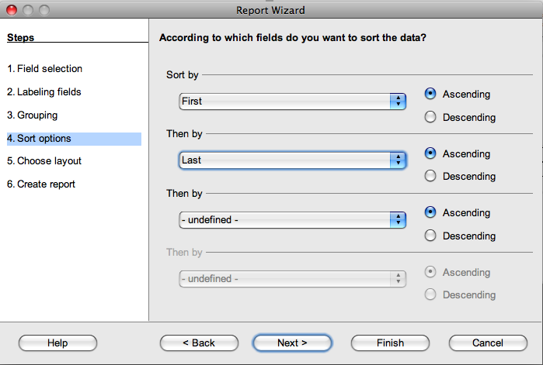
f) Sort by the most obvious fields. (First ascending followed by Last ascending was selected in the sample)
- When done, click on the Next button.

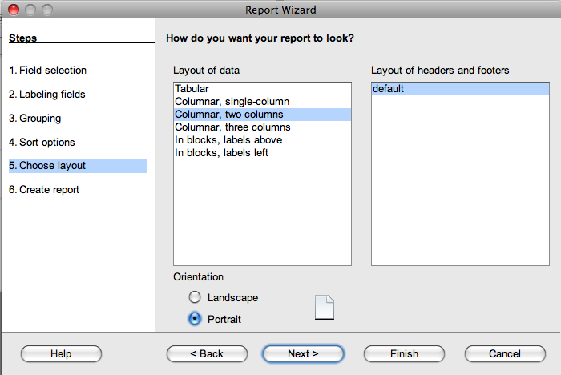
g) For the layout screen: (2 columns)
- Select Columnar, two columns
- For Orientation, select Portrait
- Click on the Next button.

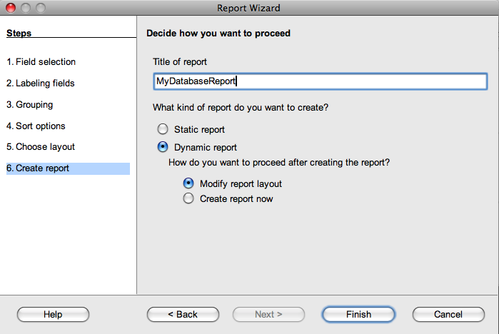
h) Saving your Report

- Give it a Report-type name
- Select Dynamic Report
- Select Modify report layout

- Click on the Finish button

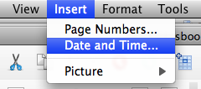

i) Add Date and Time to report Header

- From the Insert menu, select Date and Time

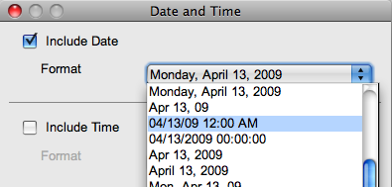
- From the menu that pops up, select the Date and Time format as shown here

- Note that the "Include Time" box is deselected in this window

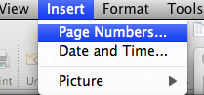
- From the Insert menu, select Page numbers

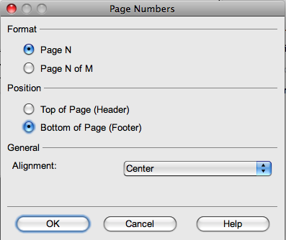
- From the Date and Time pop-up menu, select Page N option and Bottom of Page option. Click on OK when done.

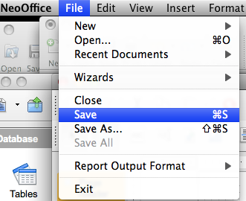
- From the File menu, select Save

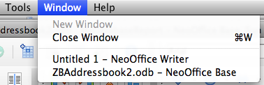
j) Open your report from the main module window.
- From the Window menu, select the name of your database.
- Save your database again.

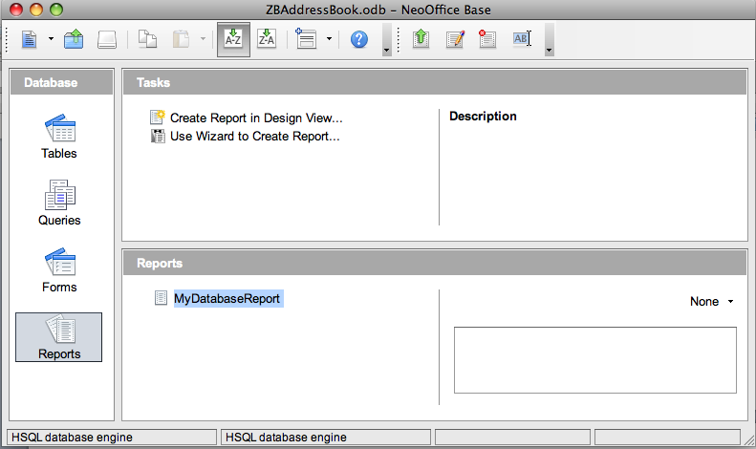

- Select the Report icon
- Double-click on the report you just created to open it

7. Printing out the report.

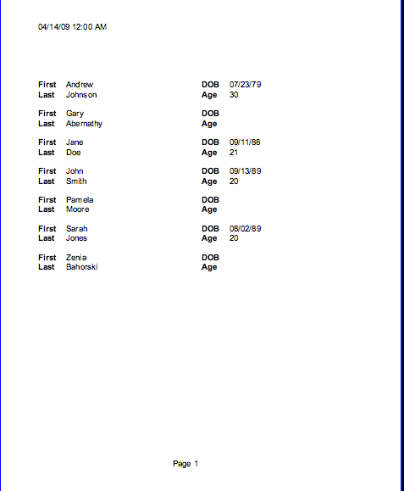
- From the File menu, select Print.
- This is your second printout.
- See the sample output for this second printout.

